Alto Den-Sin is a leading supplier of high-pressure cleaning equipment for the marine industry. It provides for more than 900 vessels worldwide. Based in Singapore since 1992, it has always strived to become the best in its field. To help it achieve this goal, the company recently deployed a business management solution to improve efficiencies and its customer service. Employees now have effective coordination across all of their departments.
Customer: Alto Den-Sin
Web Site: www.densin.com
Customer Size:
Country or Region: Singapore
Industry: Manufacturing

Customer Profile
Established in Singapore in 1992, Alto Den-Sin has become a leading supplier of high-pressure cleaning equipment for the marine industry. It provides for more than 900 vessels worldwide.

Software and Services
- Products
- Microsoft Dynamics NAV
For more information about other Microsoft customer successes, please visit: www.microsoft.com/resources/casestudies

Business Needs
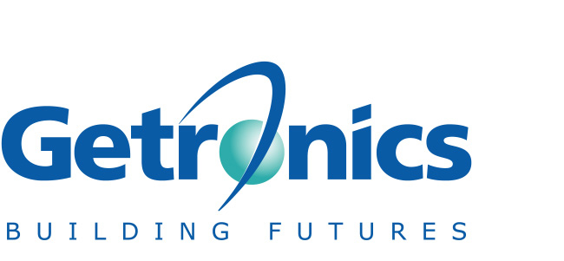 |  |  | 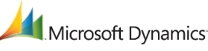

Financial employees at Alto Den-Sin had been using ACCPAC, which runs on the Windows® platform, as their accounting solution for many years. But as the company expanded, the solution could no longer keep pace with changing requirements. When demand for information at Alto Den-Sin grew, employees realized the system also had limited availability.
Jesilynn Luar, Finance Manager, Alto Den-Sin, says: “For our management employees, insufficient data recorded for detailed reports of the company’s performance seriously hampered their decision-making process. This jeopardized the company’s goal of knowing its markets and customer needs better than the competition.”

The ACCPAC solution was difficult to customize, so the possibility of increasing the number of reports was also limited. To do any sort of adaption required the expertise of technology consultants who were quite costly.

Even the information residing in the system was difficult to access. Because the solution was so loosely integrated, employees had to update the system from different sources manually. Employees continually had to re-key information from documents such as invoices and delivery orders, which increased the risk of errors and delays. “Our business processes were inefficient due to duplication of work by different employees,” Luar says. “We needed a replacement solution that would provide us greater versatility.”

Solution
When employees at Alto Den-Sin investigated new finance solutions, they evaluated offerings from SAP, JD Edwards, and Microsoft® Dynamics™ NAV. They found that Microsoft Dynamics NAV was the best fit for their business needs because, at Alto Den-Sin, a user-friendly and easy-to-maintain solution was key.
“Solutions from SAP and JD Edwards were too technical for us,” Luar says. “NAV, on the other hand, is very user-friendly for our staff, and maintaining it is also relatively easy. This was important because our employees do not have in-depth knowledge of technology. As a Microsoft product, our teams were very comfortable with the familiar interface.”
Microsoft Dynamics NAV is business management software that offers Alto Den-Sin a powerful solution that can be tailored to its needs at an affordable price. It can also adapt as the company expands even further and have more power and functionality added in a pay-as-you-grow approach.

Alto Den-Sin employed Microsoft Certified Partner ap-BIS Consulting to deploy the Microsoft Dynamics NAV solution, which has been implemented at Alto Den-Sin’s headquarters in Singapore and at its Malaysian subsidiary. Once business information was migrated to the new solution, employees at Alto Den-Sin were also trained by the team at ap-BIS Consulting and provided with a support hotline.
Luar says: “Microsoft Dynamics NAV was ideal for us largely because of its feature-rich functionality. We use the General Ledger, Accounts Receivables, Accounts Payable, Warehouse and Distribution, and Production modules from the solution in our day-to-day processes.”

Since Alto Den-Sin deployed the solution, it is no longer restricted in terms of business growth. The limitations employees had with the previous system have disappeared. And so has the need to input manual updates, which was resulting in duplicate information.

Benefits
Business decision-makers at Alto Den-Sin now have real-time financial information at their fingertips. Employees have streamlined existing processes and improved efficiency and productivity. And different divisions and subsidiaries can input their data directly into the system. “With the old system, we needed five days to close accounts at the end of each month,” Luar says. “Now, with Microsoft Dynamics NAV, our financial employees can complete them in just three days, sometimes even less.”
With the solution’s ability to customize and analyze a range of information, financial employees can satisfy detailed reporting requirements from the head office. Management has better access to accurate and reliable information, and the planning and decision-making process is enhanced.

Real-time information puts Alto Den-Sin in a better position to deliver greater value to its customers. Luar says: “Under the old system, we could never be sure if the information was current. For example, if stock inventory information was not updated in time, we risked failing to order materials in time and causing production delays. If we can’t deliver our goods in time, it affects our sales and customer experience.”
Other benefits include:
- End-of-month accounts reconciliation reduced by two days.
- Executive employees enjoy easier, faster access to comprehensive business information.
- Business processes streamlined to create efficiencies.
- No need for external consultants.
- Detailed reporting for management—employees can drag and drop information from the system into Microsoft Office Excel®.
- Improved availability of customer information improves service delivery.
- Managers can detect and track issues affecting business and take corrective action much sooner.
- Internal employees can do basic customization of the system, lowering support costs.

